**DIGITAL LOGIC DESIGN EL-227**

**Project Report**

**Buzzer wire game**

**Group members:**

Fabiha Atique 20k-0369

Syed Kumail Askari 20k-0455

Mohammad Usama 20-0190

**Introduction:**

Buzz wire game is a simple yet challenging hand game. We play number of touches against time .The players has to maintain a balance between speed and skill in order to win.

**Objective:**

The objective behind this project was attach some creativity with the concepts of logic circuits

**Background:**

The research was done from many different websites so that we can apply the simplest yet a creative approach of creating the game.

**Components:**

* Iron wires
* Battery
* Buzzer
* Jumper
* Covered wires
* Wood fra

**Circuit:**

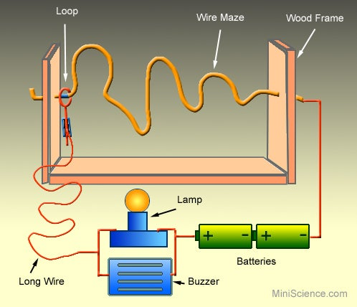

The wire maze will be connected to the negative terminal of the battery ,the positive terminal will be connected to the positive side of the LED strip .. The loop will be connected to the negative terminal of the LED strip.

**Implementation:**

So, **Buzz wire** currently exists a steady hand game that object over there currently exists well known to many just as a table top amusement. Buzz wire currently exists a challenging in addition to competitive game at whatever place the reader currently are playing the number of touches against time. The player has to get the right balance between speed in addition to skill in order to obtain the a successful score.

Following are the steps all of us follow to make the project

***Step 1:***

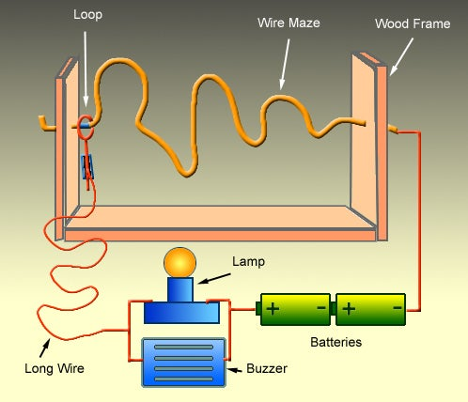For those of the reader who don’t know the game, the aim exists to guide the grip mounted loop through the wire maze without touching the loop against the metal maze every single one the way to the end.

If the metal loop touches the maze, even for a fraction of a second, the alarm will sound in addition to the player must start again.

**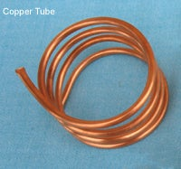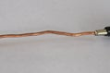*Step 2: Material***

* Iron wires
* Battery
* Buzzer
* Jumper
* Covered wires
* Wood frame

***Step 3: Make Frame And Maze***

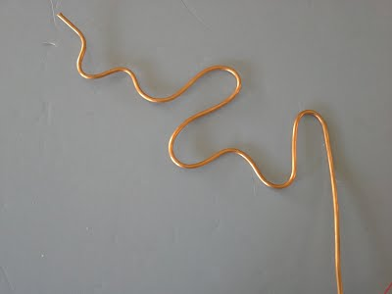

Design your own Buzz wire frame. Twist it (like a wave) by curves and corner to make the difficulty level.

***Step 4: Make A Circuit***

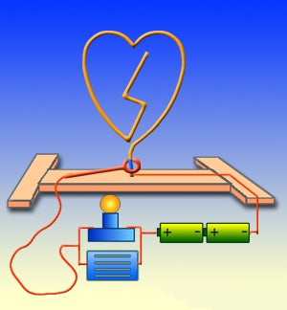

First recognize the positive and Negative end of the component. Look for + signs in addition to - signs that object over there mark the positive in addition to negative sides. Red wires indicate positive in addition to black wires indicate negative. (the diagram in the right currently exists showing every single one connection with red line.)

Decide about the location of the components based on your design and install them securely on the board or frame you have prepared. If you are using a wooden base or frame, you can use screws to mount the components such as lamp holder, battery holder and buzzer. Note that only bare wire can create an electrical contact. Carefully remove the wire insulation from the contact points as needed.

***Step 5: Design Your Loop Wand***

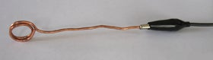

The Loop is a solid copper wire that have made a Loop on one end of it. Make a Loop of copper wire in such a way it’s one end in warped or connect with an alligator clip for easy connection.

***Step 6: Make All The Connection***

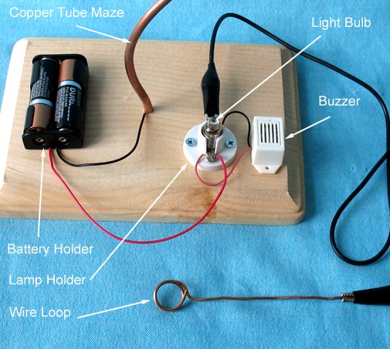

Connect the negative side of your power source (or the black wire of your battery holder) to your wire maze. (We made a hole the same size as the maze diameter, then inserted the black wire in the hole before inserting the maze in the base board.

Connect the positive side of your power source (the red wire of the battery holder) and the red wire of the buzzer together and to one side of the lamp holder. Connect the black wire of the buzzer to the other side of the lamp holder and then to the loop wand.